

**University College London**

Department of Information Studies

MSc Information Science

**Student Number (SRN):** 20040340

**Module Code and Title:** INST0012 Database Theory and Practise

**Lecturer Name:** Dr Rob Miller

**Assignment:** Assessment 1

**February 19th 2021**

# EER DIAGRAM (CHEN NOTATION) FOR THE SCENARIO:

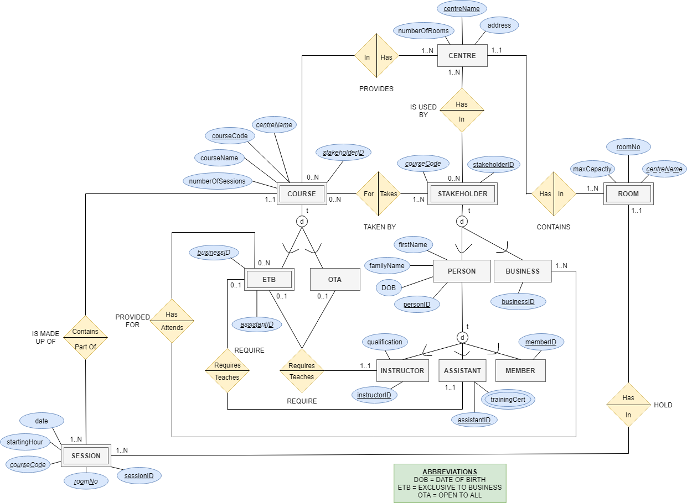

# ASSUMPTIONS:

* Each instructor can only instruct one course
* Each assistant can only assist one course
* People cannot be an instructor and an assistant at the same time (and vice versa)
* People cannot be a member and a trainer/assistant at the same time (and vice versa)
* Stakeholders can register for multiple courses

# CONSTRAINTS OF SCENARIO:

The scenario has resulted in a constrained database conceptual model. As a result, some elements need to be monitored on the application level:

* Although starting hour, centre and room number are recorded, there is no way of stopping different course sessions being held in the same centre, the same room, at the same time. Therefore, there needs to be a check for clashes when there are sessions of this nature arise.
* The schema is not designed to record the centre at which a stakeholder registered their membership. This will have to be monitored on the application level.
* The model cannot model temporal constraints (e.g. instructor must teach three courses a month, members can only take one course per centre).

# COMMENTS:

* In *word.io* there is no option to do a perfect dotted line under text. Therefore for my foreign keys (attributes) for a weak entity, I underlined each second letter, to create the effect of a dotted underline. The text was also in italics.
* *Grey rectangles* are representing entities, *Yellow diamonds* are representing the relationship between entities, and *Blue ovals* are representing the attributes of entities.